**An Intelligent Student Job Prediction Using Educational Data Analytics**

**Abstract**

The education crisis is now widely spread in global in term of decreasing number of student and decreasing degree requirements for some jobs. Educational institutes look for more efficient technology that assist better management and support decision making procedures or assist them to set new strategies. One of the effective ways to address the challenges for improving the quality is to provide new knowledge related to the educational processes and entities to the managerial system. With the data science techniques the knowledge can be extracted from operational and historical data that resides within the educational organization’s databases using. The dataset for system implementation contains information about past data of students.

Educational data mining (EDM) is recently interested in data mining area to discover useful knowledge in educational data to help educators improve their administration planning and student services. This system proposes applying of data science techniques in educational data. Association rule applied in students data to find some knowledge for supporting management planning. Data Science algorithms applied in course grades and job data of graduated student to predict job after graduated. The results of these studies give good knowledge for student management planning and job prediction. The main objective of the proposed system is to find the correlations between the student educational parameters with the types of the job.

**Introduction**

The primary aim of students who join professional courses in higher learning institutions is to secure a well paid job in a reputed organization. Professional education can be either completely technical or it can be managerial as well. Technology courses provides technical education to students in various fields such as Computer Science and Engineering, Electronics and Communication Engineering, Civil Engineering Mechanical Engineering, etc. This degree/ post graduate is aimed at making students experts in state of the art conjectural as well as practical knowledge in various engineering branches. The prediction of job status that students are most likely to achieve will help students to put in more hard work to make appropriate progress in stepping into a career in various technical fields. It will also help the teachers as well as others in an institution to provide proper care towards the improvement of students in the duration of course. A high placement rate is a key entity in building the reputation of an educational institution. Hence such a system has a significant place in the educational system of any higher learning institution.

**Existing System :**

*Student management system* – tool which maintains student academic details such as marks, attendance, admission, fees, sports, placement cell etc. but doesn’t provides any useful information related to students job prediction.

*General Counseling* – this is manual system where college staffs will sit and conduct counseling for the students to know the mental issues they are facing. This is manual process and too time consuming.

*Human Advisors* **–** this system is also manual where experts gives their opinions, suggestions for the jobs. Manual process which requires time, experience and money.

*Limitations of Existing System*

It is clear from the details of existing system that the whole system is complex and required a lot of manual work.

* Less Efficient
* Lack of Knowledge
* Time consuming
* Less Reliable
* Lack of customized services
* Expensive

**Motivation**

Student Performance improvement with job oriented in education sector is helpful for education institutes to improvise their reputations. Identification of different factors which affects a student’s learning behavior and performance during academic career. Construction of a prediction model using classification data science techniques on the bases of identified predictive variables.

**Proposed System**

Proposed system is an educational system which uses data science to process educational data. Here system process previous students data such as grades on top 3 subjects, area of interest and the aggregate using data mining technique. The main objective is to predict the correlation between student parameters with the job types. In the Proposed system we can consider the job types such as “IT”, “NON IT”, “BANK”, “EDUCATION”,”GOVT” etc. System provides the useful information which helps education sector to identify the factors related to the student jobs. The system uses Data Science approach which provides valid information from existing students to manage relationships with upcoming students and to identify the most effective factor to determine a student’s job and then adjusting these factors to improve the students performance. Proposed system is a web based application which makes use of data mining technique for the extraction of useful information.

**Student Parameters**

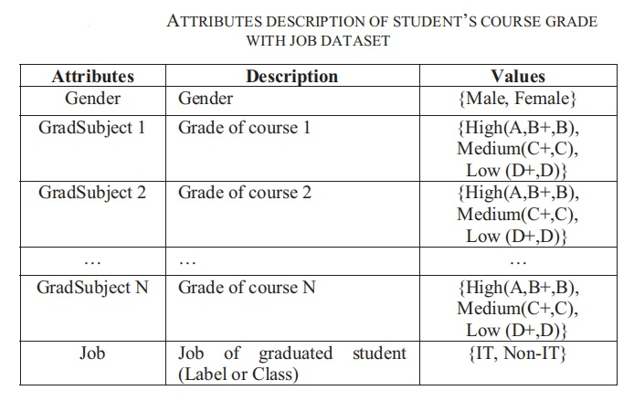

**Objectives of the Proposed System**

* Proposed project is a student job prediction and management system which is meant for educational institute.
* Proposed project makes use of Data Science technique for the job prediction of future.
* To improve the performance of the student.
* The main objective is to predict the correlation between student parameters with the job types.
* To provide valid information from existing students to manage relationships with upcoming students.
* Identification of different factors which affects a student’s learning behavior and performance during academic career.
* Visual Studio and SQL Server used to develop this project.

**Proposed System Output**

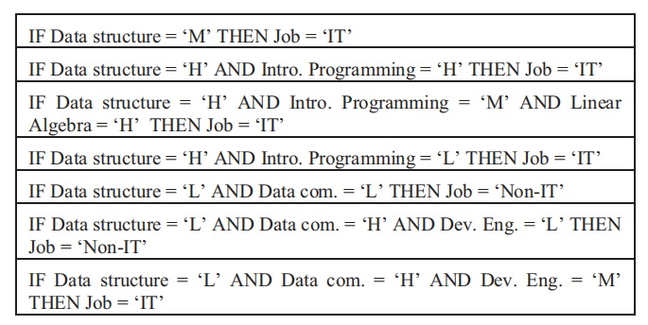

**Conclusion**

In this work, we applied data mining algorithms to discover useful knowledge from educational dataset. First, the association rule mining is used on student dataset to answer the question “how data mining can help student management working process”. The result shown the significant relationship between student parameters and job types. This result might be help educators who response for management working process to plan their admission promotion. Then algorithm is applied to student’s course grade with job dataset to answer the question “how data mining can predict the student’s jobs”. The result rule show that the significant subject which student should be important for future career.

**REFERENCES**

[1] N. Elgendy and A. Elragal. Big Data Analytics: A Literature Review Paper, Industrial Conference on Data Mining (ICDM), 2014, pp214-227.

[2] Heikki, Mannila, Data mining: machine learning statistics, and database, IEEE, 1996.

[3] Jiawei Han and Micheline Kamber (2011) Data Mining: Concepts and Techniques. 3 editions. Morgan Kaufmann.

[4] N. Elgendy and A. Elragal. Big Data Analytics: A Literature Review Paper, Industrial Conference on Data Mining (ICDM), 2014, pp214-227.

[5] Heikki, Mannila. Data mining: machine learning statistics, and database, IEEE, 1996.

[6] AlejandroPeña-Ayala. Educational data mining: A survey and a data mining-based analysis of recent works, Expert Systems with Applications, March, 2014, Vol. 41(4).